Alumni-Dev 27-01-2026 MANUAL

Introduction:

As part of the quality assurance process, a manual audit has been initiated to validate the results generated by the automated vulnerability scanning tools. Each finding is being reviewed to determine its accuracy and relevance, with the objective of classifying them as either true positives (valid security issues) or false positives (non-exploitable or misidentified issues).
This step ensures the reliability of the final report by eliminating noise from automated tools and confirming the presence and impact of vulnerabilities through manual testing techniques. The scan is done twice a month

Table of Contents
Introduction: 2
Dsm-Dev 05-01-2026 Manual 4
Executive Summary 4
SQL Injection 4
TLS Certificate 6
Client-Side JSON Injection (DOM-Based) 7
Cookie Manipulation (DOM Based) 10
Content Security Policy allow listed Script resources 11
Content Security Policy allows un-trusted script execution 13
Content Security Policy allows un-trusted style execution 15
Content Security Policy Allows Click Jacking 17
Input Returned in Response (reflected) 19
Frameable Response (Potential Click jacking) 21
Browser cross-site scripting filter disabled 22
HTML5 Storage Manipulation Test (DOM Based) 23
Email addresses disclosed 24
Credit card numbers disclosed 25
Cacheable HTTPS Response 26
Base64-encoded data in parameter 27

Alumni-Dev 27-01-2026 Manual

Executive Summary
The chart below shows the aggregated numbers of issues identified in each category for the automated Done on 27-01-2026. Solid colored bars represent issues with a confidence level of Certain, and the bars fade as the confidence level falls

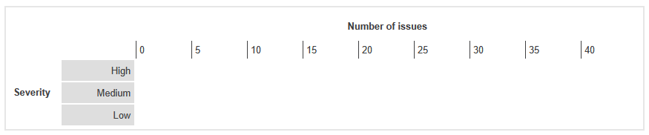

Content Security Policy allow listed Script resources
Severity | Information
Finding Type | False positive

Description
Content Security Policy (CSP) is a security mechanism designed to mitigate cross-site scripting attacks by disabling dangerous behaviors such as untrusted JavaScript execution. Websites can specify their security policy in a response header or meta tag, enabling fine-grained control over dangerous features like scripts and stylesheets.
Links Tested
- /api/content/news
- /api/employees/510-04000083
- /zalaris-site-logo.svg
The Content security Policy of Dsm-dev portal is given below
default-src 'self' *.zalaris.de *.zalaris.com https://s3.scriptcdn.net/cdn/c7fa7451-6f95-4815-ac32-b8cc2537837a https://login.microsoftonline.com/ https://dzudiostorage.blob.core.windows.net/ *.b2clogin.com https://pzudiostorage.blob.core.windows.net/ https://northeurope-2.in.applicationinsights.azure.com/v2/track https://northeurope-2.in.applicationinsights.azure.com//v2/track https://js.monitor.azure.com/scripts/b/ai.config.1.cfg.json https://cdn.form.io/ace/1.4.12/mode-html.js https://cdn.form.io/ace/1.4.12/mode-json.js https://cdn.form.io/flatpickr/flatpickr.min.js https://cdn.form.io/ace/1.4.10/ace.js https://cdn.form.io/ace/1.4.10/theme-xcode.js https://cdn.form.io/ace/1.4.10/mode-html.js https://cdn.form.io/ace/1.4.10/mode-json.js https://cdn.form.io/ace/1.4.10/worker-html.js https://cdn.form.io/ace/1.4.10/worker-json.js https://cdn.form.io/flatpickr/flatpickr.min.css https://view.officeapps.live.com/op/embed.aspx https://alumnidev.b2clogin.com/alumnidev.onmicrosoft.com/ https://helpdesk-dev.zalaris.com/ https://helpdesk-test.zalaris.com/ https://alhvbcpn2.accounts.cloud.sap dzudiostorage.blob.core.windows.net https://northeurope-0.in.applicationinsights.azure.com/v2/track https://js.monitor.azure.com/scripts/ https://ar2hdcts7.accounts.cloud.sap; script-src 'self' blob:; img-src 'self' blob: data: dzudiostorage.blob.core.windows.net https://pzudiostorage.blob.core.windows.net/ https://dzudiostorage.blob.core.windows.net/; style-src 'unsafe-inline' 'self' mypayslip-dev.zalaris.com mypayslip.zalaris.com; media-src 'self' https://dzudiostorage.blob.core.windows.net/ https://pzudiostorage.blob.core.windows.net/ https://zudioinnomotics.blob.core.windows.net/; font-src data: 'self'; frame-src 'self' blob: mypayslip.zalaris.com mypayslip-dev.zalaris.com https://dzudiostorage.blob.core.windows.net/ https://view.officeapps.live.com/; frame-ancestors 'self' blob: *.zalaris.de *.zalaris.com; form-action 'self'; worker-src 'self' blob:;
Steps:
- Capture the content security policy of Alumni-dev.zalaris.com
- The script resources are not public domains but controlled domains
- This prevents any scripts from being executed from a third-party domain within the application
- Test by fetching a Js script from the third party domain for testing:

The following command can be used to execute third party scripts
let script= document.createElement('script');
script.src='https://cdn.jsdelivr.net/npm/lodash@4.17.21/lodash.min.js'
script.onload=()=>console.log('Lodash Version:',_.VERSION);
document.head.appendChild(script);

The applications content security policy detects the script fetching and prevents it with the following response in the console
VM63:4 Loading the script 'https://cdn.jsdelivr.net/npm/lodash@4.17.21/lodash.min.js' violates the following Content Security Policy directive: "script-src 'self' blob:". Note that 'script-src-elem' was not explicitly set, so 'script-src' is used as a fallback. The action has been blocked.

The alert is false positive

WORKLOG

When | What | Who | Recommended Action
22 January 2026 | Manually tested the alert ‘content security policy allow-listed script resources’ | CSOC | No action Needed the alert is considered as false positive

Content Security Policy allows un-trusted style execution
Severity | Information
Finding Type | False positive

Description
Content Security Policy (CSP) is a security mechanism designed to mitigate cross-site scripting attacks by disabling dangerous behaviors such as untrusted JavaScript execution. Websites can specify their security policy in a response header or meta tag, enabling fine-grained control over dangerous features like scripts and stylesheets.

The following links are tested
- /
Steps:
The following needs to be tested
- Inline script via innerHTML injection
- eval () execution test
- Function Constructor (also must blocked by unsafe-eval)
- Data: URL Script Injection

Inner Script via innerHTML injection
Console command to test for the inner script injection
let div=document.createElement('div');
div.innerHTML ='<img src=x onerror="alert (XSS via inner HTML)">'
document.body.appendChild(div);
The CSP is not accepting the script execution output for the same is attached below
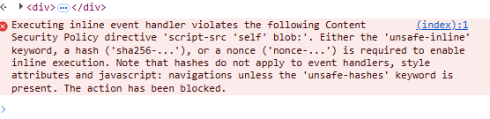
Function constructor (must be blocked by unsafe-eval)
Console command to test for function constructor
try {let fn =new Function("alert('Function constructor allowed')");fn();}catch(e){console.log("Function constructor blocked by CSP:",e.message);}

The CSP prevents the function constructor , screenshot for the same is attached below
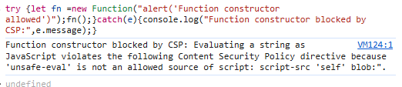

Eval () Execution test
Console command to test for eval() execution

try { eval("alert('Eval allowed - unsafe-eval is enabled')"); } catch (e) { console.error("Eval blocked by CSP", e.message); }

The eval() function is not executed within the console screenshot for the same is attached below

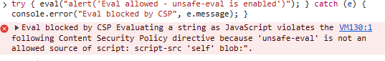

WORKLOG

When | What | Who | Recommended Action
22 January 2026 | Manually Tested Content Security Policy Allows un-trusted Script execution alert | CSOC | No action needed the alert is false positive

Content Security Policy Allows Click Jacking

Severity | Information
Finding Type | False Positive

Description
Content Security Policy (CSP) is a security mechanism designed to mitigate cross-site scripting attacks by disabling dangerous behaviours such as untrusted JavaScript execution. Websites can specify their security policy in a response header or meta tag, enabling fine-grained control over dangerous features like scripts and stylesheets.

Details

The CSP for the application is given below

default-src 'self' *.zalaris.de *.zalaris.com https://s3.scriptcdn.net/cdn/c7fa7451-6f95-4815-ac32-b8cc2537837a https://login.microsoftonline.com/ https://dzudiostorage.blob.core.windows.net/ *.b2clogin.com https://pzudiostorage.blob.core.windows.net/ https://northeurope-2.in.applicationinsights.azure.com/v2/track https://northeurope-2.in.applicationinsights.azure.com//v2/track https://js.monitor.azure.com/scripts/b/ai.config.1.cfg.json https://cdn.form.io/ace/1.4.12/mode-html.js https://cdn.form.io/ace/1.4.12/mode-json.js https://cdn.form.io/flatpickr/flatpickr.min.js https://cdn.form.io/ace/1.4.10/ace.js https://cdn.form.io/ace/1.4.10/theme-xcode.js https://cdn.form.io/ace/1.4.10/mode-html.js https://cdn.form.io/ace/1.4.10/mode-json.js https://cdn.form.io/ace/1.4.10/worker-html.js https://cdn.form.io/ace/1.4.10/worker-json.js https://cdn.form.io/flatpickr/flatpickr.min.css https://view.officeapps.live.com/op/embed.aspx https://alumnidev.b2clogin.com/alumnidev.onmicrosoft.com/ https://helpdesk-dev.zalaris.com/ https://helpdesk-test.zalaris.com/ https://alhvbcpn2.accounts.cloud.sap dzudiostorage.blob.core.windows.net https://northeurope-0.in.applicationinsights.azure.com/v2/track https://js.monitor.azure.com/scripts/ https://ar2hdcts7.accounts.cloud.sap; script-src 'self' blob:; img-src 'self' blob: data: dzudiostorage.blob.core.windows.net https://pzudiostorage.blob.core.windows.net/ https://dzudiostorage.blob.core.windows.net/; style-src 'unsafe-inline' 'self' mypayslip-dev.zalaris.com mypayslip.zalaris.com; media-src 'self' https://dzudiostorage.blob.core.windows.net/ https://pzudiostorage.blob.core.windows.net/ https://zudioinnomotics.blob.core.windows.net/; font-src data: 'self'; frame-src 'self' blob: mypayslip.zalaris.com mypayslip-dev.zalaris.com https://dzudiostorage.blob.core.windows.net/ https://view.officeapps.live.com/; frame-ancestors 'self' blob: *.zalaris.de *.zalaris.com; form-action 'self'; worker-src 'self' blob:;

- The frame ancestors has been set to ‘self’
- Try to access dsm-dev.zalaris.com inside an iframe
- The following code can be used to render the site in an iframe

- The application refuses to connect in an iframe
- Refer screenshot attached below for evidence

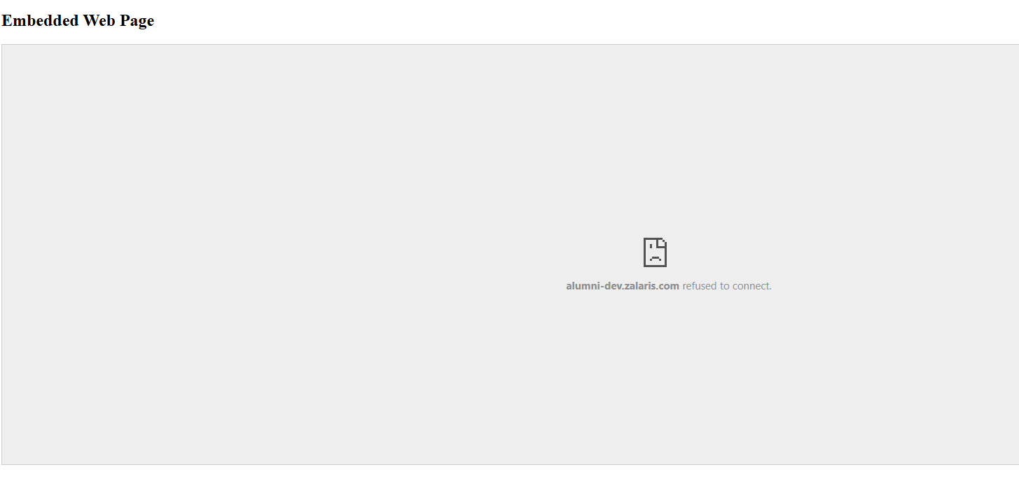

- The application is not vulnerable to clickjacking
- The alert is false positive

WORKLOG

When | What | Who | Recommended Action
22 January 2026 | Manually Tested Content Security Policy Allows Click jacking | CSOC | No Action needed the alert is false positive

External DNS Interaction

Severity | Information
Finding Type | False Positive

Description

It is possible to induce the application to perform server-side DNS lookups of arbitrary domain names.
The payload 4glkwzdpd3t4wfldz3qile4hx831rsfle94wukj.oastify.com was submitted in the SSL SNI value and the HTTP Host header.
The application performed a DNS lookup of the specified domain.

Links Reported

- /api/content/6911fc301f9fa0185ca3431e

Details

- Login into Alumni-dev.zalaris.com/
- Capture a request and alter the host-name
- Forward the request to see whether the application fetches the resource
- The application throws 404 error and is not fetching the resource
- Refer screenshot attached below for evidence
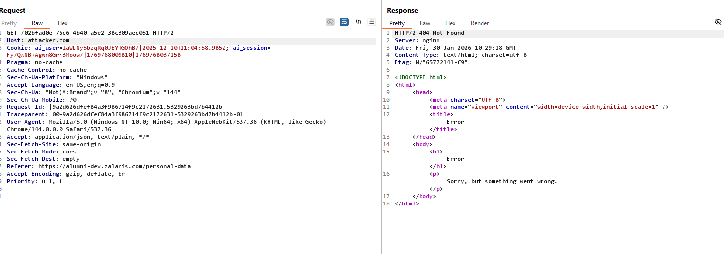

The alert is false positive

WORKLOG

When | What | Who | Recommended Action
22 January 2026 | Manually Tested External DNS Interaction | CSOC | No Action needed alert is False positive.

Input Returned in Response (reflected)

Severity | Information
Finding Type | Informational

Links Reported
- /api/content/news [URL path filename]
- /api/content/news [URL path folder 2]
- /api/employees/099-10001022/payroll-results [URL path filename]
- /api/employees/099-10001022/payroll-results [URL path folder 2]
- /api/employees/099-10001022/payroll-results [URL path folder 3]
- /api/employees/099-10001022/personal-data [URL path filename]
- /api/employees/099-10001022/personal-data [URL path folder 2]
- /api/employees/099-10001022/personal-data [URL path folder 3]
- /api/employees/510-04000083 [URL path filename]
- /api/employees/510-04000083 [URL path folder 2]
- /api/employees/510-04000083/documents [URL path filename]
- /api/employees/510-04000083/documents [URL path folder 2]
- /api/employees/510-04000083/documents [URL path folder 3]
- /api/employees/510-04000083/payroll-results [URL path filename]
- /api/employees/510-04000083/payroll-results [URL path folder 2]
- /api/employees/510-04000083/payroll-results [URL path folder 3]
- /api/employees/510-04000083/personal-data [URL path folder 2]
- /api/employees/510-08001000 [URL path filename]
- /api/employees/510-08001000 [URL path folder 2]
- /api/employees/510-08001000/documents [URL path filename]
- /api/employees/510-08001000/documents [URL path folder 3]
- /api/employees/510-08001000/payroll-results [URL path filename]
- /api/employees/510-08001000/payroll-results [URL path folder 3]
- /api/employees/510-08001000/personal-data [URL path filename]
- /api/employees/510-08001000/personal-data [URL path folder 3]
- /api/employees/employment/history [URL path filename]
- /api/employees/employment/history [URL path folder 3]

Description
Reflection of input arises when data is copied from a request and echoed into the application's immediate response.
Input being returned in application responses is not a vulnerability in its own right. However, it is a prerequisite for many client-side vulnerabilities, including cross-site scripting, open redirection, content spoofing, and response header injection. Additionally, some server-side vulnerabilities such as SQL injection are often easier to identify and exploit when input is returned in responses. In applications where input retrieval is rare and the environment is resistant to automated testing (for example, due to a web application firewall), it might be worth subjecting instances of it to focused manual testing.

Details

- Login into Alumni-dev.zalaris.com/777
- Capture the request using Burp alter the path, inject the payload and forward the request
- The server returns 404 Not found and the payload is reflected in the response
- The payload is sanitized, and no issue is found
- Refer Screenshot attached below for evidence
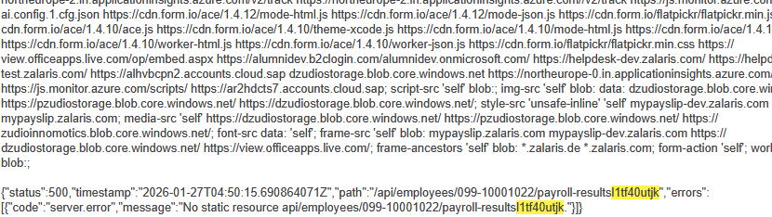
The alert is informational as the injected payload is reflected but is not executed as payload

WORKLOG

When | What | Who | Recommended Action
22 January 2026 | Manually Tested Input returned in response (reflected) | CSOC | No Action needed Informational

Frame-able Response (Potential Click jacking)
Severity | Information
Finding Type | Informational

Description

If a page fails to set an appropriate X-Frame-Options or Content-Security-Policy HTTP header, it might be possible for a page controlled by an attacker to load it within an iframe. This may enable a clickjacking attack, in which the attacker's page overlays the target application's interface with a different interface provided by the attacker. By inducing victim users to perform actions such as mouse clicks and keystrokes, the attacker can cause them to unwittingly carry out actions within the application that is being targeted. This technique allows the attacker to circumvent defenses against cross-site request forgery and may result in unauthorized actions.

Note that some applications attempt to prevent these attacks from within the HTML page itself, using "framebusting" code. However, this type of defense is normally ineffective and can usually be circumvented by a skilled attacker.
You should determine whether any functions accessible within frameable pages can be used by application users to perform any sensitive actions within the application.

Details

Duplicate alert already tested in Clickjacking alert .

The alert is false positive . No action needed

Worklog

When | What | Who | Recommended Action
22 January 2026 | Duplicate alert | CSOC | Duplicate alert

Browser cross-site scripting filter disabled
Severity | Information
Finding Type | False positive

Issue detail
This issue was found in multiple locations under the reported path.
Issue background
Some browsers, including Internet Explorer, contain built-in filters designed to protect against cross-site scripting (XSS) attacks. Applications can instruct browsers to disable this filter by setting the following response header:

X-XSS-Protection: 0

This behavior does not in itself constitute a vulnerability; in some cases XSS filters may themselves be leveraged to perform attacks against application users. However, in typical situations XSS filters do provide basic protection for application users against some XSS vulnerabilities in applications. The presence of this header should be reviewed to establish whether it affects the application's security posture.

Issue remediation
Review whether the application needs to disable XSS filters. In most cases you can gain the protection provided by XSS filters without the associated risks by using the following response header:

X-XSS-Protection: 1; mode=block

When this header is set, browsers that detect an XSS attack will simply render a blank page instead of attempting to sanitize the injected script. This behavior is considerably less likely to introduce new security issues.

The alert is false positive as the header is obsolete

WORKLOG

When | What | Who | Recommended Action | Action plan
05 January 2026 | Manually tested Browser cross-site scripting filter disabled | CSOC | No Issues Found | No action Needed the alert is considered as false positive

HTML5 Storage Manipulation Test (DOM Based)

Severity | Information
Finding Type | False Positive

Description

DOM-based vulnerabilities arise when a client-side script reads data from a controllable part of the DOM (for example, the URL) and processes this data in an unsafe way.

HTML5 storage manipulation arises when a script stores controllable data in the HTML5 storage of the web browser (either localStorage or sessionStorage). An attacker may be able to use this behavior to construct a URL that, if visited by another application user, will cause the user's browser to store attacker-controllable data.

This behavior does not in itself constitute a security vulnerability. However, if the application later reads the data back from storage and processes it in an unsafe way, then an attacker may be able to leverage the storage mechanism to deliver other DOM-based attacks, such as cross-site scripting and JavaScript injection.

Burp Suite automatically identifies this issue using dynamic and static code analysis. Static analysis can lead to false positives that are not actually exploitable. If Burp Scanner has not provided any evidence resulting from dynamic analysis, you should review the relevant code and execution paths to determine whether this vulnerability is indeed present, or whether mitigations are in place that would prevent exploitation.

Links Reported

- /
- /
- /locales/gb/locale.json
- /locales/gb/locale.json
- /zalaris-site-logo.svg
- /zalaris-site-logo.svg

Details

The value that is passed on from the source to sink is related to Microsoft Azure Insights and is not sensitive

Refer Screenshot for evidence

[{"item":"{\"time\":\"2026-01-27T04:47:49.403Z\",\"iKey\":\"9b454807-9d03-4ea0-ae51-041c8d9edf86\",\"name\":\"Microsoft.ApplicationInsights.9b4548079d034ea0ae51041c8d9edf86.RemoteDependency\",\"tags\":{\"ai.user.id\":\"Uyfn/1dLGNvPhsj8Odg7XG\",\"ai.session.id\":\"FhmSaYDoHdnrGDMMVrHOPV\",\"ai.device.id\":\"browser\",\"ai.device.type\":\"Browser\",\"ai.operation.name\":\"/////ru0u37rl4y%27%22%60'%22/ru0u37rl4y/%3E%3Cru0u37rl4y//%3Ercb6m629fx&\",\"ai.operation.id\":\"8bf608aeb4e84b5ea975f352a0bc8426\",\"ai.cloud.role\":\"alumni-webapp\",\"ai.internal.sdkVersion\":\"javascript:3.3.10\"},\"data\":{\"baseType\":\"RemoteDependencyData\",\"baseData\":{\"id\":\"|8bf608aeb4e84b5ea975f352a0bc8426.c3d6d5b3e8224fd2.\",\"ver\":2,\"name\":\"GET /locales/en/locale.json\",\"resultCode\":\"200\",\"duration\":\"00:00:00.415\",\"success\":true,\"data\":\"GET /locales/en/locale.json\",\"target\":\"alumni-dev.zalaris.com\",\"type\":\"Fetch\",\"properties\":{\"HttpMethod\":\"GET\"},\"measurements\":{}}}}","cnt":0},{"item":"{\"time\":\"2026-01-27T04:47:49.381Z\",\"iKey\":\"9b454807-9d03-4ea0-ae51-041c8d9edf86\",\"name\":\"Microsoft.ApplicationInsights.9b4548079d034ea0ae51041c8d9edf86.RemoteDependency\",\"tags\":{\"ai.user.id\":\"Uyfn/1dLGNvPhsj8Odg7XG\",\"ai.session.id\":\"FhmSaYDoHdnrGDMMVrHOPV\",\"ai.device.id\":\"browser\",\"ai.device.type\":\"Browser\",\"ai.operation.name\":\"/////ru0u37rl4y%27%22%60'%22/ru0u37rl4y/%3E%3Cru0u37rl4y//%3Ercb6m629fx&\",\"ai.operation.id\":\"8bf608aeb4e84b5ea975f352a0bc8426\",\"ai.cloud.role\":\"alumni-webapp\",\"ai.internal.sdkVersion\":\"javascript:3.3.10\"},\"data\":{\"baseType\":\"RemoteDependencyData\",\"baseData\":{\"id\":\"|8bf608aeb4e84b5ea975f352a0bc8426.ca08f6236ed94fac.\",\"ver\":2,\"name\":\"GET /locales/en-GB/locale.json\",\"resultCode\":\"200\",\"duration\":\"00:00:00.494\",\"success\":true,\"data\":\"GET /locales/en-GB/locale.json\",\"target\":\"alumni-dev.zalaris.com\",\"type\":\"Fetch\",\"properties\":{\"HttpMethod\":\"GET\"},\"measurements\":{}}}}","cnt":0}]

- The alert is false positive

WORKLOG

When | What | Who | Recommended Action
22 January 2026 | Manually Tested HTML5 Storage Manipulation Test (DOM Based) | CSOC | No Action needed alert is false positive

Robots.txt
Severity | Low
Finding Type | Informational

Description
The file robots.txt is used to give instructions to web robots, such as search engine crawlers, about locations within the web site that robots are allowed, or not allowed, to crawl and index.
The presence of the robots.txt does not in itself present any kind of security vulnerability. However, it is often used to identify restricted or private areas of a site's contents. The information in the file may therefore help an attacker to map out the site's contents, especially if some of the locations identified are not linked from elsewhere in the site. If the application relies on robots.txt to protect access to these areas, and does not enforce proper access control over them, then this presents a serious vulnerability.
Details
The robots.txt file is accessible but , no sensitive content is found . Refer screenshot attached below for evidence
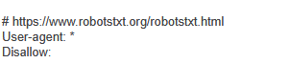
WORKLOG

When | What | Who | Recommended Action | Action plan
22 January 2026 | Manually tested alert robots.txt found | CSOC | No Issues Found | No action Needed the alert is informational

Cache-able HTTP Response
Severity | Information
Finding Type | False positive
Description

Unless directed otherwise, browsers may store a local cached copy of content received from web servers. Some browsers, including Internet Explorer, cache content accessed via HTTPS. If sensitive information in application responses is stored in the local cache, then this may be retrieved by other users who have access to the same computer at a future time.

Link Reported
- /
- /country-flags/de.svg
- /locales/gb/locale.json
Details

The links that are reported are non sensitive and do not need cache protection

The alert is false positive
WORKLOG

When | What | Who | Recommended Action | Action plan
22 January 2026 | Manually tested alert Cache-able HTTPs Response | CSOC | No Issues Found | No action Needed the alert is false positive

TLS Certificate
Severity | Information
Finding Type | False positive
Description

The server presented a valid, trusted TLS certificate. This issue is purely informational.
The server presented the following certificates:

Server certificate
Issued to: | *.zalaris.com, zalaris.com
Issued by: | DigiCert Global G2 TLS RSA SHA256 2020 CA1
Valid from: | Wed Aug 06 05:30:00 IST 2025
Valid to: | Tue Mar 24 05:29:59 IST 2026

Certificate chain #1
Issued to: | DigiCert Global G2 TLS RSA SHA256 2020 CA1
Issued by: | DigiCert Global Root G2
Valid from: | Tue Mar 30 05:30:00 IST 2021
Valid to: | Sun Mar 30 05:29:59 IST 2031

Certificate chain #2
Issued to: | DigiCert Global Root G2
Issued by: | DigiCert Global Root G2
Valid from: | Thu Aug 01 17:30:00 IST 2013
Valid to: | Fri Jan 15 17:30:00 IST 2038

Overall Score
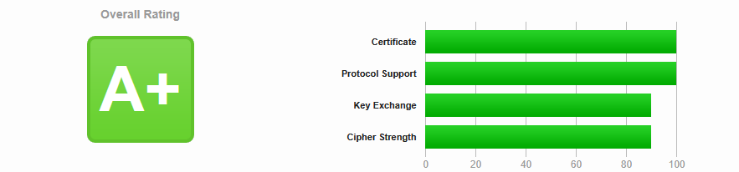
Certificate Validity
SSL/TLS certificate validation confirmed the certificate is active and within its validity period as of the test date

TLS protocols supported

The target supports TLS protocols supported are 1.2 and 1.3 which are considered as secure for current use

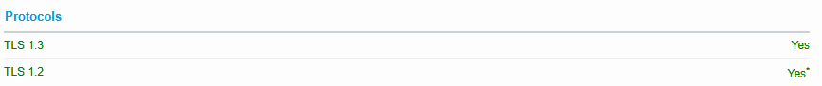

Cipher Suites supported

The following cipher suites are used and are secure

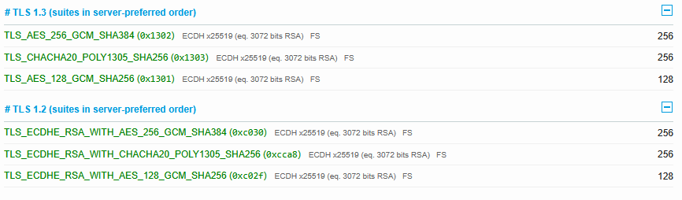
No Issues are found the alert is informational

WORKLOG
When | What | Who | Recommended Action
22 January 2026 | Manually Tested TLS Certificate alert for issues | CSOC | No action needed alert is informational

